Jet Ranger Cockpit – User Guide
Oct 11, 2026 · @Peter

Overview
The Jet Ranger cockpit drives real gauge needles, warning lights, radio displays and switches from the simulator. A Windows PC exchanges UDP packets over Ethernet with five Arduino Mega 2560 panel boards, and a small USB board presents the panel switches to Windows as joysticks.
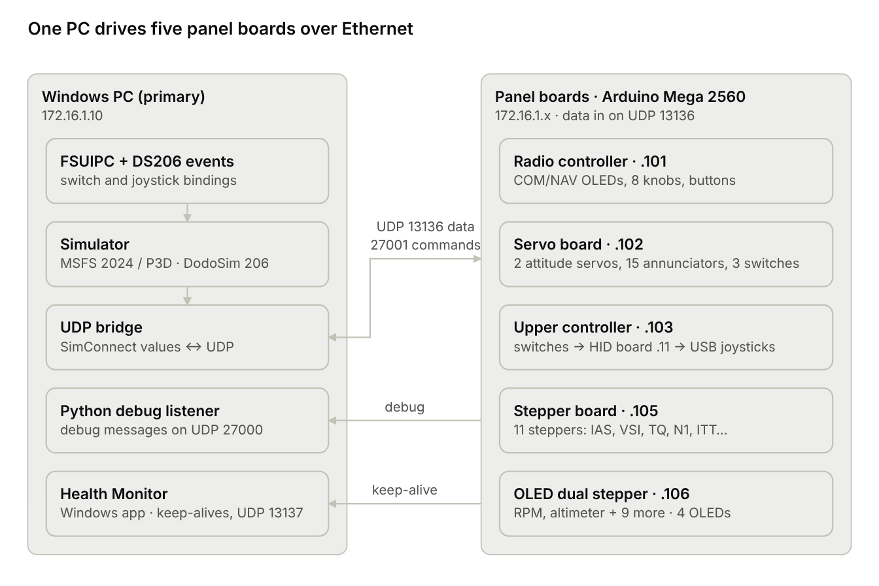
system overview · PC and five panel boards
Data flows one way, PC to board. On the primary PC, a Python listener shows the board's debug messages and a separate Windows app, the Health Monitor, tracks its keep-alives. Cockpit switches reach the simulator separately, as FSUIPC events.
Part | Hardware / software | Address | Section
Primary PC | Windows, MSFS 2024 or P3D, DodoSim 206 V2, UDP bridge, Python debug listener, Health Monitor | 172.16.1.10 | Windows and simulator
Radio controller | Mega 2560 on the Prod Radio Controller PCB + COM and NAV panel | 172.16.1.101 | Radio controller
Servo board | Mega 2560 + Ethernet module on the Front Panel Servo PCB | 172.16.1.102 | Arduino servo controller
Upper controller | Mega 2560 scanning the overhead switch matrix | 172.16.1.103 | Joystick (HID) interface
Stepper board | Mega 2560 on the Jet Ranger 13 Stepper PCB | 172.16.1.105 | Stepper controller
OLED dual stepper | Mega 2560 on the OLED Dual Stepper PCB | 172.16.1.106 | OLED dual stepper controller
USB HID board | Leonardo-class board with native USB | 172.16.1.11 | Joystick (HID) interface

Windows and simulator
The Windows PC runs the simulator and a bridge program that turns simulator variables into UDP text packets for the Arduino. Switch inputs travel the other way as simulator events.
The FSUIPC bridge sends the Servo, Stepper and Dual Stepper boards each their own packet in real units (degrees, knots, feet per minute, psi, percent, degrees C), and the boards convert them with their own calibration. It sends about 10 packets per second to each board; the radio gets a packet whenever a frequency changes and at least every 5 s. The Dual Stepper's temperature OLED shows the outside air temperature from the simulator.
MSFSWinformsAutoCS is the Microsoft Flight Simulator 2020 / 2024 version of the same bridge: it reads the values through SimConnect and sends the same packets to the same boards, so the panel behaves the same with either. Run only one bridge at a time, because both listen for the radio board's commands on UDP 27001. It has been built and its packets tested, but not yet run against MSFS.

What runs on the PC
Component | Role | Notes
Simulator (MSFS 2024, P3D or FSX) | Flies the DodoSim 206 / Bell 206 Jet Ranger | The project also targets DCS on other airframes
UDP bridge | Reads sim variables over SimConnect, and sends D, packets to each panel board on UDP 13136 | In the repo as FSUIPCWinformsAutoCS, MSFSWinformsAutoCS, P3D_to_UDP, SimConnect_to_UDP and MSFSSimConnectExtractor, one per simulator
FSUIPC + DODSIM206V2.EVT | Exposes 234 DodoSim custom events so cockpit switches and buttons can be bound | P3D / FSX only
Python debug listener | Shows debug messages from the servo board | Listens on UDP 27000
Health Monitor | Windows app that tracks each board's keep-alive and flags a board that goes quiet | Listens on UDP 13137; the servo board sends SERVO every 10 s
The bridge sends real units: degrees for the attitude indicator, and knots, ft/min, °C, psi, % or US gallons for the gauges. Each board turns them into a servo position or stepper steps with calibration tables in its own sketch.

Running the MSFS bridge
1. Build the project MSFSWinformsAutoCS (in the repo's C# Code folder) and run MSFSWinformsAutoCS.exe from its bin\Debug folder. Build output is not stored in git, so a fresh copy of the repo has to be built first.
2. Close the FSUIPC bridge if it is running, then start MSFS and load a Jet Ranger. The order does not matter: the bridge keeps looking for the simulator. The status bar changes from Disconnected (red) to Connected to MSFS with the aircraft name (green) once data arrives.
3. The window lists the values being sent and the warning lamps. The Avionics Master box follows the simulator and can also be used to switch it.
4. If the status turns orange and says no data, the simulator is paused or loading and the bridge has stopped sending; the boards return their gauges to zero after 30 s and carry on when data returns.
5. Only the engine out, rotor low and low fuel lamps are driven, because the other lamps need aircraft-specific variables. Some MSFS Jet Rangers do not report every value (for example transmission pressure and temperature), so those gauges may stay at zero.

Installing the DodoSim event file (FSUIPC)
- Copy DODSIM206V2.EVT into the {P3D or FSX}/Modules folder, next to FSUIPC.ini.
- Add this to FSUIPC.ini if FSUIPC has not added it itself:
[EventFiles]
0=DodoSim206
- Restart the simulator. The DS206.* events now appear in FSUIPC's button and key assignment lists.
- Bind each physical switch to its event. After an EVT update, FSUIPC re-indexes events alphabetically, so check and re-map bindings.

Event naming
Suffix | Parameter | Behaviour | Example
_SET | Integer (usually 1 = on, 0 = off) | Sets a state directly; best for latching toggle switches | DS206.BATTERY_SWITCH_SET
_TOGGLE | None | Flips the state each press | DS206.FUEL_VALVE_SWITCH_TOGGLE
_TRIGGER | None (some take 1–10 as a multiplier) | Momentary; reverts when the event stops. Tick Control to repeat while held | DS206.STARTER_BUTTON_TRIGGER
none | None | One-shot action | DS206.CLOCK_MODE_BUTTON
For physical latching switches, prefer the _SET events: send 1 on switch-on and 0 on switch-off so the sim never drifts out of step with the panel.

Event groups at a glance
Group | Event numbers | Examples
Circuit breakers | 36–95, 107–110 | Hoist, SAS, fuel pumps, governor, ignition, starter
Lights and master switches | 96–101, 111–122, 209–212, 224–227 | Battery, generator, avionics, pitot heat, landing lights
Engine and flight controls | 1–2, 207–208, 213–223, 228–232 | Rotor brake, hydraulics, force trim, starter, governor beep
Instruments | 3–33 | Annunciator test, AI cage, radar altimeter, HSI and OBS knobs
Radios and audio | 129–192 | COM/NAV swap and tuning, ADF, DME, audio panel
Transponder | 193–206 | Mode knob, digit buttons, IDT, VFR
SAS modes | 123–128 | Master, HDG, NAV, SPD, ALT, VRT
Other | 102–106, 233–234 | Difficulty rotary, heat/vent, external power

Network
All devices sit on one wired 172.16.1.x subnet with fixed addresses; there is no DHCP on the servo board.
Device | IP address | MAC | Keep-alive text
Primary PC (simulator, Python debug listener, Health Monitor) | 172.16.1.10 | – | –
USB HID board | 172.16.1.11 | DE:AD:BE:EF:FE:ED | JOYSTICK
Radio controller | 172.16.1.101 | A8:61:0A:9E:83:01 | COMM_NAV
Servo board | 172.16.1.102 | A8:61:0A:9E:83:02 | SERVO
Upper controller | 172.16.1.103 | A8:61:0A:9E:83:03 | UPPER_INPUT
Stepper board | 172.16.1.105 | A8:61:0A:67:83:69 | STEPPER
OLED dual stepper | 172.16.1.106 | A8:61:0A:67:83:6A | DUAL_STEPPER
Every live board has its own IP and MAC address. Some bench and retired sketches reuse a live board's address: Stepper-Tuning-Harness and Jet_Ranger_Driver_Test use the stepper board's (.105), the retired dual stepper sketch uses .106 and JoystickSimple uses .11. Keep a board running one of those off the cockpit network, or change its address first.
The firmware sends its debug and keep-alive traffic to 172.16.1.10 (reflectorIP), so the primary PC must hold that address, or reflectorIP must be changed and the sketch re-uploaded.
UDP port | Direction | Purpose
13136 | PC → panel boards | Gauge, annunciator and radio data (D,) and control (C,) packets
27001 | radio controller → PC bridge | Standby frequencies and button commands such as COM1_RADIO_SWAP
4210 | upper controller → USB HID board | Switch changes (index,state) and keypad keys (KEY,key,state)
13137 | boards → Health Monitor | Keep-alive text every 10 s (see table above)
27000 | boards → Python debug listener | Debug messages, each prefixed with the board name
7788 | listening on boards | Opened at start-up, not used yet

Packet format
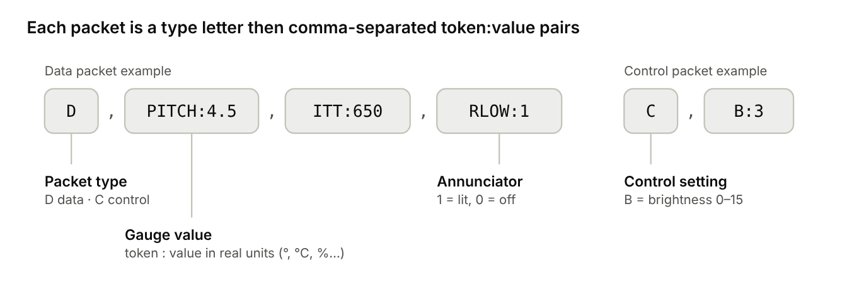
UDP packet format · data and control
A packet can carry any number of pairs, in any order, up to 1000 bytes. Unknown tokens are ignored, so the PC can send only the values that changed. For example, D,PITCH:5,BANK:-10,LOWF:0 sent to the servo board sets the attitude indicator to 5° pitch and −10° bank and turns off Low Fuel.
To test without the simulator, send a packet from a PC on the subnet, for example with PowerShell:
$u = New-Object System.Net.Sockets.UdpClient
$b = [Text.Encoding]::ASCII.GetBytes('D,PITCH:5,RLOW:1')
$u.Send($b, $b.Length, '172.16.1.102', 13136)

Arduino servo controller
The servo board is an Arduino Mega 2560 with an Ethernet module, on the Jet Ranger Front Panel Servo PCB at 172.16.1.102. It drives the attitude indicator's two servos, switches the 15 caution and warning annunciators and reads three front-panel switches. It runs JET_RANGER_SERVO_CONTROLLER.ino.
The other gauges that were once servo-driven (airspeed, VSI, torque, temperatures, pressures, fuel and RPM) now run on the two stepper boards.

Uploading the firmware
- Open the sketch in the Arduino IDE and select Board: Arduino Mega or Mega 2560.
- Install the libraries it uses: Ethernet (with SPI), Servo, Ewma (jonnieZG) and DCS-BIOS.
- Upload, then watch the start-up self-test (below): both servos sweep and all 15 lamps light.

Servos
Instrument | Mega pin | UDP token | Range
Attitude bank (roll) | 27 | BANK | −90° to +90°
Attitude pitch | 26 | PITCH | −30° to +30°
Both tokens take attitude in degrees, with one decimal place allowed (for example D,PITCH:4.5,BANK:-12). The board turns degrees into a servo position with the tables in Calibration. BANKRAW and PITCHRAW take a raw servo position (0–180) and skip the tables, for calibration work.
The PCB still has 16 servo headers from the earlier design; only pins 26 and 27 are used.

Other pins
Function | Pin | Behaviour
Green status LED | 14 | Flashes alternately with red every 200 ms while running
Red status LED | 15 | Fast flash during the 3 s Ethernet start-up; then alternates with green
Ethernet module reset | 53 | Pulsed low for 2 ms at power-up
Annunciators | A1–A15 | Digital outputs, HIGH = lit (see Reference)
Ethernet SPI | 50–52 + CS | Standard Mega SPI pins used by the Ethernet library
TOT clear switch | 43 | Switch to GND, debounced 30 ms; each change goes to the USB HID board as Joystick 1 button 9 (index 8)
Warning mute switch | 47 | Switch to GND, debounced 30 ms; each change goes to the USB HID board as Joystick 1 button 8 (index 7)
Fuel valve switch | 48 | Switch to GND, debounced 30 ms; each change goes to the USB HID board as Joystick 1 button 10 (index 9)
The 15 annunciator tokens and their pins are listed in Reference: UDP tokens.

What happens at power-up
- All 15 annunciators switch on as a lamp test.
- The Ethernet module is reset and starts at 172.16.1.102; the red LED flashes for 3 s.
- Ethernet Started goes to the Python debug listener.
- Pitch, then bank, sweeps from minimum to maximum and back (about 2 s each) and parks at its calibrated level position.
- All annunciators switch off.
- The starting state of the three front-panel switches is sent to the USB HID board, Setup Complete is logged and the 30 s no-data watchdog starts.

Normal running
- Every 5 ms the board checks UDP 13136 and stores each value as a new target.
- Every 5 ms each servo steps one position towards its target, so the attitude indicator moves smoothly.
- A servo that has not moved for 1 s is detached to stop buzz; the next movement re-attaches it.
- Annunciators change as soon as a 0 or 1 arrives.
- Each front-panel switch change is debounced for 30 ms and sent to the USB HID board at 172.16.1.11:4210 as index,state (1 = closed).
- Every 10 s the board sends SERVO to the Health Monitor on UDP 13137.
- If no packet arrives for 30 s, both servos return to level and every annunciator goes out; the next packet brings them back.
- C,SWINGPITCH:1 or C,SWINGBANK:1 re-runs one sweep on demand. The board pauses for about 2 s while it runs.

Stepper controller (13 Stepper board)
A second Arduino Mega 2560, on the Jet Ranger 13 Stepper PCB at 172.16.1.105, drives 11 X27-style stepper gauges directly from its pins. Unlike the servo board, it takes real units (knots, fpm, °C, psi, %, US gallons) and converts them to needle steps with calibration tables in the sketch JET_RANGER_STEPPER_CONTROLLER.ino.

Gauges
Gauge | Stepper | Mega pins | UDP token | Units | Calibration
Airspeed | IASstepper | 12, 13, 22, 23 | IAS | knots, 0–140 | 9-point table
Vertical speed | VSIstepper | 7, 8, 9, 11 | VSI | fpm, ±1750 | Table
Radar altitude | RadarAltStepper | 32–35 | AGL | raw steps | Not calibrated yet
Torque | TQstepper | 36–39 | TQ | %, 0–120 | 2-point table
Gas producer (N1) | GPstepper | 40–43 | N1 | %, 0–105 | 3-point table
Turbine outlet temp | EGTstepper | A11–A14 | ITT | °C | 7-point table
Fuel quantity | FAstepper | 2, 3, 4, 6 | FUEL | US gal, 0–75 | 2-point table
Engine oil temp | EOTstepper | 48, A0–A2 | OILT | °C | Placeholder linear scale
Engine oil pressure | EOPstepper | 44–47 | OILP | psi | Placeholder linear scale
Transmission oil temp | XOTstepper | A3–A6 | XMSNT | °C | Placeholder linear scale
Transmission oil pressure | XOPstepper | A7–A10 | XMSNP | psi | Placeholder linear scale
Every token has a raw twin with RAW on the end (for example IASRAW:300). It moves the needle by raw steps and skips the calibration table, which is how you measure new calibration points on the bench. Pins 24–31 are free since Turbine and Rotor RPM moved to the OLED dual stepper board.

Behaviour
- Power-up: status LEDs flash, Ethernet starts, backlighting ramps up, then each gauge does a self-test sweep in turn: fuel, torque, ITT, N1, VSI, IAS, radar altitude. Each sweep has its own on/off switch (SwingFA, SwingTQ and so on) near the top of the sketch.
- Running: every 5 ms the board checks UDP 13136 and moves each needle towards its target with smooth acceleration.
- No-data watchdog: if no packet arrives for 30 s, every needle returns to its zero.
- Zero trims: each gauge has a …ZeroOffset value to nudge its true zero without touching the calibration table.
- Keep-alive: sends STEPPER to the Health Monitor on UDP 13137 every 10 s; debug goes to the Python listener on UDP 27000.

Testing a gauge on demand
Send a control packet to re-run one gauge's sweep without rebooting, for example C,SWINGTQ:1.
Command | Gauge
SWINGFUEL | Fuel quantity
SWINGTQ | Torque
SWINGITT | Turbine outlet temp
SWINGN1 | Gas producer
SWINGVSI | Vertical speed
SWINGIAS | Airspeed
SWINGAGL | Radar altitude
The StepperVSITester app in the repo can send every token and raw token to this board without the simulator running.
The SwingTester app in the repo sends these commands (and the dual stepper and servo sweeps) one at a time or all in a fixed order, lights the OLEDs and the annunciators during the run and sends a keep-alive so the boards' 30 s watchdogs do not fire. Airspeed and radar altitude now return to zero after the full-scale wind-up instead of 635 steps past it, and take about 10 s each.
SwingTester's Reset boards... button reboots the boards you tick (Radio, Servo, Upper, Stepper, Dual Stepper, USB HID) by sending each one C,RESET:1; see the reference tokens. Each board restarts about 2 s later and repeats its power-up test.

Known issues
- Fixed 12 Oct 2026: the backlight PWM was set to pin 8, which the PCB routes to VSI coil B. It is now pin 5, matching the PCB's BACKLIGHT_PWM net, in both stepper sketches.
- Pins 9 and 32 are also claimed by the unused SAI pitch servo and SARI roll stepper.
- Oil, transmission and the four placeholder gauges still use a shared linear scale, not bench-measured tables.

OLED dual stepper controller
A third Mega, on the Jet Ranger OLED Dual Stepper PCB at 172.16.1.106, drives 11 stepper gauges plus four small OLED displays. It runs JET_RANGER_OLED_DUAL_STEPPER_CONTROLLER.ino and, like the 13 Stepper board, takes real units.

Gauges
Gauge | Stepper | Mega pins | UDP token | Units | Calibration
Engine RPM (N2) | TSstepper | 24–27 | RPME | %, 0–110, one decimal | 4-point table + TSoffset
Rotor RPM | RSstepper | 28–31 | RPMR | %, 0–110, one decimal | 4-point table + RSoffset
Altimeter | ALTstepper | 40–43, zero sensor A15 | ALT | feet | 720 steps per 1000 ft
Fuel load | FuelLoadStepper | 32–35 | FUELLOAD | psi | 2-point table (0–30 psi)
Electrical load | ElectricalLoadStepper | 36–39 | ELECTRICALLOAD | % | 2-point table
Engine oil temp | EOTstepper | 48, A0–A2 | OILT | °C | 4-point table
Engine oil pressure | EOPstepper | 44–47 | OILP | psi | 4-point table
Transmission oil temp | XOTstepper | A3–A6 | XMSNT | °C | 4-point table
Transmission oil pressure | XOPstepper | A7–A10 | XMSNP | psi | 5-point table
Turbine outlet temp | EGTstepper | A11–A14 | ITT | °C | As 13 Stepper board
Fuel quantity | FAstepper | 2, 3, 4, 6 | FUEL | US gal | As 13 Stepper board
Oil, transmission, ITT and fuel tokens are accepted by both stepper boards. Wire each physical gauge to one board only; the matching channel on the other board then simply has nothing connected. Each token also has a RAW twin for bench work.
IAS accepts a decimal: the FSUIPC bridge sends airspeed to one decimal place (for example D,IAS:93.4) and the board interpolates between the calibration rows with it. Around 50 knots half a knot is about 3 steps, so the needle moves smoothly rather than in whole-knot jumps.

OLED displays
The four 128×32 SSD1306 OLEDs share the Mega's I2C pins (20 SDA, 21 SCL) through a TCA9548A multiplexer at address 0x70. The firmware pulses the mux reset on pin 16 at start-up.
Display | Mux channel | UDP token | Shows
Barometric setting | 1 | none yet | 2992 at boot; not updated
Altimeter digits | 2 | ALT | Rolling-drum altitude, raw MSL (baro correction off)
Clock | 3 | ZULU | Zulu time from HHMM, e.g. ZULU:1430
Temperature | 4 | TEMP | Text as sent, e.g. TEMP:25C
Send C,OLEDTEST:1 to light all four displays solid, and C,OLEDTEST:0 to restore them.
When the main bus is below 24 V the bridge sends PWR:0 and all four displays (barometric setting, altimeter, clock and temperature) go blank; PWR:1 turns them back on and they repaint within about a second. The altimeter needle keeps following altitude. The lamp test still lights all four displays whatever PWR says.

Behaviour
- Power-up: OLEDs start first, then each gauge sweeps in turn: engine oil pressure, engine oil temp, transmission pressure, transmission temp, electrical load, fuel load, engine RPM, rotor RPM, altimeter. The altimeter seeks its zero sensor before sweeping. Start-up takes about 65 s.
- No-data watchdog: after 30 s without a packet, needles return to zero and all OLEDs blank.
- On-demand sweeps: C,SWINGOILP:1, SWINGOILT, SWINGXMSNP, SWINGXMSNT, SWINGELECTRICALLOAD, SWINGFUELLOAD, SWINGRPME, SWINGRPMR, SWINGALT. Each blocks the board for 5–7 s.
- Fuel load and electrical load now sweep with the same 315-step range and homing as the engine and transmission oil gauges (they used 630 steps before), so their sweeps should be shorter; they have not been re-timed yet.
- Keep-alive: sends DUAL_STEPPER to the Health Monitor every 10 s, so it shows separately from the 13 Stepper board.

Known issues
- RAM use is 75%; avoid adding more OLEDs or string-heavy code.
- The latest bench I2C scan found OLEDs on mux channels 1 to 4 (the clock and temperature displays answer); check by eye that each shows its text.
- Engine and rotor RPM tables assume 0% = 0 steps; RSoffset is not yet measured.
- The altimeter zero seek travels up to 10,080 steps, about 14 turns, before giving up.

Radio controller (COM / NAV)
The radio panel is a fourth Mega at 172.16.1.101, running JET_RANGER_RADIO_CONTROLLER.ino. It shows COM frequencies on two OLEDs, reads eight tuning knobs and a 4×4 button matrix, and sends knob and button actions back to the PC.

Boards
PCB | Role | Main parts
Jet Ranger Prod Radio Controller | Shield on the Mega; current production board (latest Gerbers Feb 2026) | Mega 2560 shield, USR-ES1 (W5500) Ethernet module, TCA9548A I2C mux
Jet Ranger COM and NAV | Front panel board behind the radio faceplate | 8 rotary encoders, 4 push buttons
Jet Ranger Radio Controller | Earlier prototype of the controller board | As production board
Jet Ranger DUE Prod Radio Controller | Arduino Due version of the controller | Due shield, USR-ES1, TCA9548A; no matching sketch in the repo

Inputs and outputs
Function | Mega pins | Notes
COM1 major / minor knob | 31, 30 / 33, 32 | Encoder A, B
COM2 major / minor knob | 34, 35 / 37, 36 | Encoder A, B
NAV1 major / minor knob | 38, 39 / 41, 40 | Encoder A, B
NAV2 major / minor knob | 42, 43 / 45, 44 | Encoder A, B
Button matrix | rows 22–25, columns 26–29 | 4×4
OLEDs | I2C via TCA9548A (0x70) | Port 0 = NAV OLED, port 1 = COM OLED, both at 0x3C
Status LEDs | 14 green, 15 red | Red flashes while Ethernet starts
Ethernet module | SPI 50–52, reset 53

Data from the PC (UDP 13136)
Token | Meaning | Example
C1A / C1S | COM1 active / standby frequency | C1A:119.500
C2A / C2S | COM2 active / standby frequency | C2S:121.900
NAVCOM1 | Radio power (0 = off) | NAVCOM1:1
NOTMAINBUS | Main bus voltage
B (control) | Display brightness | C,B:5

Commands to the PC (UDP 27001)
Turning a knob changes the standby frequency on the OLED and sends the new value to the PC. Buttons in the first column of the matrix send these commands; other buttons are only logged to the debug listener.
Button (row, col 0) | Command sent
Row 0 | NAV1_RADIO_SWAP (NAV1 FREQ switch)
Row 1 | NAV2_RADIO_SWAP (NAV2 FREQ switch)
Row 2 | COM1_RADIO_SWAP (COMM1 Freq switch)
Row 3 | COM2_RADIO_SWAP (COMM2 FREQ switch), then AVIONICS_MASTER_SET
The PC bridge (P3D_to_UDP, SimConnect_to_UDP or MSFSSimConnectExtractor, depending on the simulator) listens on 27001 and turns these into simulator events. The radio board sends COMM_NAV to the Health Monitor every 10 s; the Health Monitor turns its Comm/Nav light from green to orange, then red, when nothing arrives for 15–30 s.
The four swap switches are on the Jet Ranger COM and NAV board and share matrix column 0. NAV1 and NAV2 also swap their active and standby frequencies on the NAV OLED straight away, because the PC does not send NAV frequencies back; the COM swaps change the display only when the simulator returns the swapped frequencies. The FSUIPC bridge (FSUIPCWinformsAutoCS) handles NAV1_RADIO_SWAP and NAV2_RADIO_SWAP; the SimConnect and P3D bridges do not yet.
If no data packet arrives from the PC for 30 s and no knob or button is used, both OLEDs blank (as if the radio had no power). Turning a knob or pressing a button, or new data from the PC, switches them back on, and they blank again after another 30 s of silence. At power-up the matrix is ignored for the first 1.5 s so a floating input cannot send false button presses.
The displays also follow the aircraft's electrics: when the avionics bus is below 24 V the bridge tells the radio the power is off (NAVCOM1:0) and the COM and NAV displays go blank together; they light together again when the bus rises.
Each knob sends its standby frequency to the PC with the radio's name: COM1 as the bare number (for example 118.295), the others as COM2_STANDBY:118.295, NAV1_STANDBY:108.000 or NAV2_STANDBY:108.000. The FSUIPC bridge (FSUIPCWinformsAutoCS) tunes the matching radio. Nothing is sent during the first 1.5 s after power-up, so the knobs' start positions do not change the simulator. Each OLED line always shows two frequencies in a fixed 16-column layout (for example 128.300 127.800); the radio pads short values from the PC such as 127.80 so that COM2 and NAV2 never slide under the faceplate.
Tuning steps follow the standard channel spacing. The COM knobs run 118.000 to 136.975 MHz in 25 kHz channels (the major knob picks 118 to 136, the minor knob 000, 025, 050 and 075 after each MHz). The NAV knobs run 108.00 to 117.95 MHz in 50 kHz steps (major 108 to 117, minor 000, 050, 100 and so on). Each minor knob wraps round at the ends. 8.33 kHz channels are not offered. FSUIPC holds COM frequencies to 10 kHz, so in the simulator a channel such as 118.025 may appear as 118.02 or 118.03.

Known issues
- Only COM1 and COM2 frequencies arrive from the PC; there are no NAV frequency tokens yet, although the NAV knobs are read.
- With the SimConnect, P3D and MSFS bridges, turning a COM2, NAV1 or NAV2 knob does not tune that radio: those bridges only understand the bare COM1 standby number, and the radio now sends COM2_STANDBY:, NAV1_STANDBY: and NAV2_STANDBY: for the other three. Use the FSUIPC bridge for full radio control.
- If every button in the matrix's first column stops working, send C,MATRIX:1 to port 13136: the radio prints the raw H/L state of each column to the debug listener. A column that reads L with nothing pressed is a hardware fault on that Mega pin or board (a faulty or badly seated Mega did exactly this on the bench).

Joystick (HID) interface
Overhead and console switches reach the simulator as ordinary USB joystick buttons. The upper controller scans the switches and sends each change over UDP to a small USB board, UDP_TO_HID, which Windows sees as four joysticks and a keyboard.
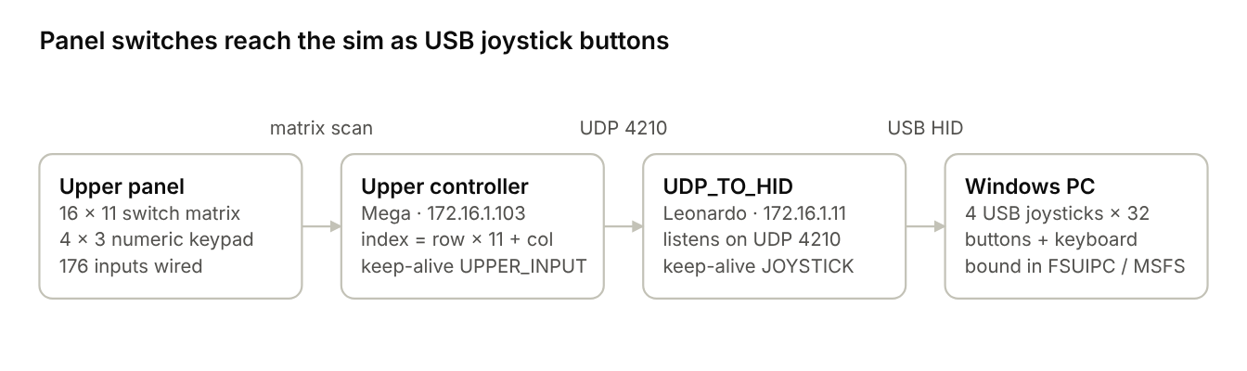
joystick (HID) path · panel to simulator
The joysticks have buttons only: no axes and no hat switches. Bind them like any other controller, in FSUIPC for P3D/FSX or in the MSFS controls menu.

Boards
Board | Sketch | Address | Role
Upper controller (Mega 2560) | JET_RANGER_UPPER_CONTROLLER.ino | 172.16.1.103 | Scans a 16 × 11 switch matrix (rows on pins 22–37, columns on 38–48) and a 4 × 3 keypad (A9–A15)
USB HID board (Leonardo-class, native USB) | UDP_TO_HID.ino | 172.16.1.11 | Listens on UDP 4210 and presents 4 joysticks × 32 buttons plus a keyboard
Servo board (Mega 2560) | JET_RANGER_SERVO_CONTROLLER.ino | 172.16.1.102 | Also sends three front-panel switches (warning mute, TOT clear, fuel valve) to the HID board as index 7, 8 and 9

How a switch becomes a joystick button
- The upper controller numbers each matrix position as index = row × 11 + column (0–175).
- When a switch changes, it sends index,state to 172.16.1.11:4210, with state 1 = switch on and 0 = off.
- The HID board picks joystick = index ÷ 32 and button = index mod 32, then holds that button down while the switch is on.
- Keypad keys are sent as KEY,<key>,<state> and typed as keyboard keys 0–9, * and #.
- The servo board sends the same index,state format for its three front-panel switches: index 7 (warning mute, pin 47), 8 (TOT clear, pin 43) and 9 (fuel valve, pin 48), with 1 = closed.
Index range | Windows device
0–31 | Joystick 1
32–63 | Joystick 2
64–95 | Joystick 3
96–127 | Joystick 4
128–175 | Not sent to Windows (out of range)

Switch mapping in use
From UpperSwitchMapping.ods. Button numbers below are as Windows and the simulators show them (1–32); the firmware counts from 0. A latching switch holds its button down while on, so bind both press and release: in FSUIPC use the _SET event with parameter 1 on press and 0 on release.
Index | Row, col | Switch | Button on = | Joystick, button | Suggested DodoSim event
0–4 | 0, 0–4 | Heater rotary | HTR 0–4 | J1, 1–5 | –
5 | 0, 5 | Air vent | Vent (off = Air Off) | J1, 6 | HEAT_VENT_SWITCH_SET
6 | 0, 6 | Air heat | Heat (off = Air Off) | J1, 7 | HEAT_VENT_SWITCH_SET
7 | Servo D47 | Warning mute | Closed | J1, 8 | DS206.WARNING_MUTE_BUTTON_SET
8 | Servo D43 | TOT clear (TOT light test) | Closed | J1, 9 | DS206.TOT_TEST_BUTTON_SET
9 | Servo D48 | Fuel valve | Closed | J1, 10 | DS206.FUEL_VALVE_SWITCH_SET
11 | 1, 0 | Fwd fuel boost breaker | On | J1, 12 | FORE_FUEL_PUMP_CB_SET
12 | 1, 1 | Aft fuel boost breaker | On | J1, 13 | AFT_FUEL_PUMP_CB_SET
13 | 1, 2 | Generator field breaker | On | J1, 14 | GENERATOR_FIELD_CB_SET
14 | 1, 3 | Generator breaker | On | J1, 15 | GENERATOR_RESET_CB_SET
15 | 1, 4 | Dir gyro / attitude ind | Att Ind (off = Dir Gyro) | J1, 16 | DIR_GYRO_SWITCH_SET
16 | 1, 5 | Battery | On | J1, 17 | BATTERY_SWITCH_SET
17 | 1, 6 | Generator | Gen On (off = Gen Start) | J1, 18 | GENERATOR_SWITCH_SET
22 | 2, 0 | Landing light | On | J1, 23 | LANDING_LIGHT_SWITCH_SET
23 | 2, 1 | Instrument lights | On | J1, 24 | PANEL_LIGHTS_SWITCH_SET
24 | 2, 2 | Caution light breaker | On | J1, 25 | CAUTION_LT_CB_SET
25 | 2, 3 | Anti-collision light | On | J1, 26 | COLLISION_LIGHTS_SET
26 | 2, 4 | Position lights | On | J1, 27 | POSITION_LIGHTS_SET
27 | 2, 5 | Pitot heat | On | J1, 28 | PITOT_HEAT_SWITCH_SET
28 | 2, 6 | Avionics | On | J1, 29 | AVIONICS_SWITCH_SET
39 | 3, 6 | Strobe light | On | J2, 8 | –
The suggested events are the closest match in DODSIM206V2.EVT; the bindings actually saved in FSUIPC or MSFS are not in the repo. All other matrix positions are wired but unassigned.

Setting FSUIPC events from the joystick buttons
A joystick button does nothing in the simulator until it is bound to an event in FSUIPC. The Warning Mute and Fuel Valve switches on the servo board must be set this way before they work; the TOT clear switch beside them is bound the same way. This applies to P3D and FSX with FSUIPC and DODSIM206V2.EVT installed (see Installing the DodoSim event file above). In MSFS, bind the buttons in the controls menu instead; the DS206 events are not available there.
1. Start the simulator with the USB HID board connected. Windows should list the four joysticks (Game Controllers, joy.cpl); pressing a switch lights the matching button there.
2. In the simulator open FSUIPC from the Add-ons menu and choose the Buttons + Switches tab.
3. Operate the switch you want to bind (for example flip the Fuel Valve switch). FSUIPC shows the joystick letter and button number it saw. Note that FSUIPC counts buttons from 0 and Windows from 1, so Windows button 10 shows as button 9 in FSUIPC.
4. Under the pressed (or closed) side, tick Select for FS control, choose the event from the list and type the parameter in the box beside it. The DS206 events are listed alphabetically.
5. A switch that stays on needs the released side set as well: tick Select for FS control there, choose the same event and enter the opposite parameter, so the cockpit follows the switch in both directions.
6. Click OK, flip the switch and check the result in the cockpit. FSUIPC keeps the assignment in its settings file, but after an event file update it re-indexes the events alphabetically, so check these bindings again.
Warning Mute: Joystick 1 button 8 (FSUIPC button 7). Event DS206.WARNING_MUTE_BUTTON_SET, parameter 1 when pressed and 0 when released. Alternatively bind DS206.WARNING_MUTE_BUTTON_TRIGGER (no parameter) to the pressed side only.
Fuel Valve: Joystick 1 button 10 (FSUIPC button 9). Event DS206.FUEL_VALVE_SWITCH_SET, parameter 1 when closed and 0 when released. The valve in the simulator follows the switch; if it ends up the wrong way round, swap the two parameters.
TOT clear (TOT light test): Joystick 1 button 9 (FSUIPC button 8). Event DS206.TOT_TEST_BUTTON_SET, parameter 1 when pressed and 0 when released.
If FSUIPC does not see a switch, check that Windows shows the button moving in joy.cpl first. If it does not, the problem is on the board side (the servo board's debug messages report each change and the HID board logs the button it sets).
Bell_206_Switch_Mappingsv1d.xlsx also plans a Leo Bodnar USB board for COM/NAV, autopilot, ADF and a hat switch; no firmware for it is in the repo.

Known issues
- The HID board's own test button on pin 5 also drives Joystick 1 button 1, the same button as HTR 0.
- CreateDcsBiosMessage() is still a stub, so these switches do nothing in DCS; only the joystick path works.
- The Health Monitor shows the HID board as JoyStick and the upper controller as Upper Input.
- The HID board also reboots when it receives C,RESET:1 (or RESET) on UDP 4210. Its USB connection drops while it restarts, so Windows briefly loses the four joysticks and the keyboard and then detects them again; re-check any game that has them open.
- The servo board's three switches use index 7, 8 and 9, which Windows shows as Joystick 1 buttons 8, 9 and 10. If they were meant to be Windows buttons 7, 8 and 9, button 7 is already the Air heat switch (index 6), so the indexes would have to move.

PCBs and wiring
The Mega sits on a carrier PCB that breaks its pins out to servo headers, annunciator outputs and the Ethernet module. The diagram and connection table below cover the servo board; the PCB index after them lists every Jet Ranger board in the repo.
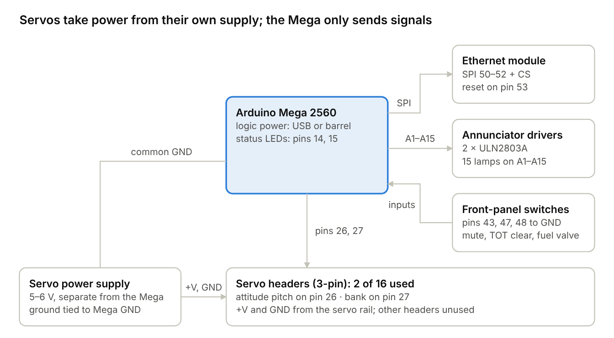
servo board wiring · power and signals
The rule that matters most: never power servos from the Mega's 5 V pin. Servos draw current spikes when they move, which can reset the Mega and drop the Ethernet link.

All Jet Ranger PCBs
KiCad projects for every board live under Jet Ranger/PCBs in the repo, with Gerbers in each MANUFACTURING folder.
PCB | Used by | Main parts
Jet Ranger Front Panel Servo | Servo board | Mega shield, servo headers, annunciator outputs
Jet Ranger 13 Stepper | Stepper board | Mega shield, USR-ES1 Ethernet, 14 six-pin gauge sockets, 12 V annunciator supply with polyfuses
Jet Ranger OLED Dual Stepper | OLED dual stepper | Mega shield, USR-ES1, six-pin gauge sockets, TCA9548A sockets for the OLEDs
Jet Ranger X27 Small Stepper | Each stepper gauge | One X27 / VID29 stepper, backlight LED, six-pin connector to the controller
Jet Ranger Prod Radio Controller | Radio controller | Mega shield, USR-ES1, TCA9548A
Jet Ranger COM and NAV | Radio panel | 8 rotary encoders, 4 push buttons
Jet Ranger Upper Controller | Upper controller | Mega shield for the switch matrix
Jet Ranger Radio Controller, DUE Prod Radio Controller, Due Controller as built | Earlier or alternative radio boards | See the Radio controller section
Jet Ranger Altimeter, Auto Pilot Audio, Test, MAX7219 Radio Test | Other panels and experiments | Not covered in this guide
The X27 steppers run straight from the Mega's pins, so the stepper boards need no driver chips; the 12 V input feeds annunciators and backlights.
PCB version 1.4 has the fixes. Jet Ranger OLED Dual Stepper version 1.4 (12 Oct 2026) separates Mega pins 2 and 32: earlier versions joined them in copper because of a copy-and-paste net name, so the fuel quantity and fuel load gauges shared coil A. On a board older than 1.4, fit only one of those two gauges or cut the trace between the pins.

Connections on the carrier board
Connector | Count | Pins | Wiring
Servo headers | 16 on the PCB, 2 used | 26 (pitch), 27 (bank); the rest are unused | Signal · +V · GND; +V from the servo rail
Annunciator outputs | 15 | A1–A15 | Pin HIGH = lamp on; through a driver for lamps above 20 mA
Spare outputs | 3 | not assigned (SPARE1–SPARE3) | Reserved for future lights
Ethernet module | 1 | SPI 50–52, chip select, reset 53 | Reset is pulsed by the firmware at start-up
Status LEDs | 2 | 14 green, 15 red | With series resistors to GND
Servo power input | 1 | – | 5–6 V; ground joined to Mega GND
Front-panel switch inputs | 3 | D43, D47, D48 | Each to GND through a switch (SW1 TOT clear, SW3 warning mute, SW2 fuel valve); internal pull-up, debounced in firmware

Wiring checklist
- ☐ Servo rail fed from its own 5–6 V supply, not the Mega
- ☐ Supply ground joined to Mega GND (signals need a shared reference)
- ☐ Each servo plugged in signal-side matching the header silkscreen
- ☐ Annunciator lamps checked during the power-up lamp test
- ☐ Ethernet cable to the same switch as the primary PC
- ☐ Board serial number noted in the sketch header

Calibration
The servo board turns attitude degrees into a servo position (0–180) with two small tables in the sketch. Between table points it interpolates in a straight line; beyond the ends it holds the end value. The stepper gauges have their own step tables, described in their sections.
Instrument | Attitude | Servo position
Pitch (PITCH_DEG_TABLE) | −30° | 179
Pitch | 0° (level) | 113
Pitch | +30° | 70
Bank (BANK_DEG_TABLE) | −90° | 5
Bank | 0° (level) | 93
Bank | +90° | 179
The self-test sweep uses aServMinPosition[] and aServMaxPosition[] (bank 5–179, pitch 166–70) and parks at aServZeroPosition[] (bank 93, pitch 113).

Calibrating a servo
- Send raw positions with BANKRAW or PITCHRAW (for example D,PITCHRAW:113), or use the ServoTuner app, until the instrument shows a known attitude.
- Note the position for each attitude you check: at least both ends and level.
- Enter them in PITCH_DEG_TABLE or BANK_DEG_TABLE, and set aServZeroPosition[] to the level position so the self-test parks there.
- Upload, then check with real values, for example D,PITCH:0 and D,BANK:30.
Do not drive a servo hard against its mechanical stop. A stalled servo draws high current and gets hot.

Troubleshooting
Symptom | Likely cause | What to check
Red LED keeps fast-flashing, no gauge sweep | Board stuck in Ethernet start-up | Ethernet module seated; reset line on pin 53; module powered
Sweep runs but gauges never move in flight | Packets not reaching UDP 13136 | PC on 172.16.1.x; Windows firewall allows outbound UDP; bridge sends to the right board (servo .102, steppers .105 and .106)
No debug messages, or Health Monitor shows the board as down | Listener or Health Monitor not running, or PC address wrong | PC at 172.16.1.10; Python listener bound to UDP 27000, Health Monitor to UDP 13137; Windows firewall allows inbound UDP on both
One gauge pinned at an end stop | Value outside the calibration table, or table points wrong | Send the RAW token to find the true limits, then re-measure the table (see Calibration)
Attitude indicator lags fast changes | 1° per 5 ms step limit | Expected; reduce servoCheckInterval to speed up
Servo buzzes or jitters | Weak servo supply | Separate 5–6 V supply for servos, common ground with the Mega
An annunciator never lights | Wiring or the light's driver | It should light at power-up lamp test; if not, check the A-pin and its driver
FSUIPC binding fires the wrong event | EVT re-indexed after an update | Re-map the binding in FSUIPC
Data reaches the boards only in bursts, with gaps of several seconds | The PC's Ethernet link to the board switch is dropping in and out | In Windows, check the Internal Sim Network adapter stays Connected; check the 5 V supply of the network switch stays above 4.75 V (it dipped below and the switch dropped its ports), then the cable and switch port

Known issues in the code
Firmware (JET_RANGER_SERVO_CONTROLLER.ino)
- Brightness packets (C,B:n) are accepted but do nothing: no pin is assigned and the PWM line is commented out. The PCB has BACKLIGHT_PWM on pin 5 ready for it.
- powerAvailable is set from NAVCOM1 but nothing uses it, so the attitude indicator and lamps stay live when the sim's power is off.
- Several annunciators log Transmission Temperature changed to the debug listener, whichever lamp changed.
- The #define comments for pins 26 and 27 still say "Using Gas Producer Port" and "Using Radar Alt Port" from the old servo layout.
- The PCB labels 10 of the 15 annunciator outputs on different pins from the sketch (A1/A2, A5/A6, A7–A10, A11/A12). Test each lamp on its own, for example D,RLOW:1, and correct whichever side is wrong.
FSUIPC event file (DODSIM206V2.EVT)
- Line before event 133 is missing its //, so FSUIPC may reject or mis-read it.
- Events 189 and 190 are named the wrong way round: 189 is called _SET but toggles, 190 is called _TOGGLE but takes 1 or 2.
- Events 69–71 mix up the instrument and cockpit light breakers: 69 is named COCKPIT_LT_CB_TOGGLE, and INST_LT_CB_SET appears twice.

Open questions
- Which of the four bridge programs is the one in daily use.
- Power supply rating for the servo rail and the 12 V annunciator supply.

Reference: UDP tokens
From the current sketches. Gauge tokens take real units; annunciator tokens take 0 (off) or 1 (on). UDP_Interface_Values.xlsx still lists the old 16-servo pin plan, so use these tables instead.

Gauge tokens
Token | Gauge | Board | Units
BANK | Attitude bank | Servo (.102) | degrees, ±90
PITCH | Attitude pitch | Servo (.102) | degrees, ±30
IAS | Airspeed | Stepper (.105) | knots, one decimal allowed
VSI | Vertical speed | Stepper (.105) | ft/min
AGL | Radar altitude | Stepper (.105) | raw steps
TQ | Engine torque | Stepper (.105) | %
N1 | Gas producer | Stepper (.105) | %
ITT | Turbine outlet temp | Stepper (.105) or OLED dual (.106) | °C
FUEL | Fuel quantity | Stepper (.105) or OLED dual (.106) | US gal
OILT | Engine oil temp | Stepper (.105) or OLED dual (.106) | °C
OILP | Engine oil pressure | Stepper (.105) or OLED dual (.106) | psi
XMSNT | Transmission oil temp | Stepper (.105) or OLED dual (.106) | °C
XMSNP | Transmission oil pressure | Stepper (.105) or OLED dual (.106) | psi
RPME | Engine RPM (N2) | OLED dual (.106) | %
RPMR | Rotor RPM | OLED dual (.106) | %
ALT | Altimeter | OLED dual (.106) | feet
FUELLOAD | Fuel load | OLED dual (.106) | psi
ELECTRICALLOAD | Electrical load | OLED dual (.106) | %
Every gauge token also has a RAW twin (for example PITCHRAW, IASRAW) that takes a raw servo position or stepper step count and skips the calibration table.

Annunciator tokens
Token | Light | Pin
EOUT | Engine out | A1
RLOW | Rotor RPM low | A2
TOPW | Transmission oil pressure | A3
TOTW | Transmission oil temp | A4
BHOT | Battery hot | A5
BTMP | Battery temp | A6
EC | Engine chip | A7
TRC | Tail rotor chip | A8
TC | Transmission chip | A9
BD | Baggage door | A10
FFLTR | Aft fuel filter | A11
FPMP | Fuel pump | A12
GENF | Generator fail | A13
LOWF | Low fuel | A14
SCF | SAS controller fail | A15

Status and control tokens
Token | Packet | Meaning
NAVCOM1 | D | 0 = avionics bus below 24 V (radio COM and NAV displays blank), 1 = on
B | C | Panel brightness 0–15 (not yet active)
SWING<CODE> | C | Runs one gauge's start-up sweep on demand, for example C,SWINGTQ:1 (stepper boards) or C,SWINGPITCH:1 and C,SWINGBANK:1 (servo board); the value is ignored
OLEDTEST | C | 1 fills the four OLEDs solid white, 0 restores them (dual stepper board)
KEEPALIVE | C | Ignored command that still counts as received data and restarts the 30 s no-data timer (SwingTester sends it during a run)
RESET | C | Reboots the board through its watchdog about 2 s later (servo, stepper, dual stepper, radio and upper controllers on port 13136; USB HID board on port 4210). SwingTester's Reset boards... button sends it. The radio controller reboots with a software reset (a watchdog reset hung its bootloader) and has been tested; the upper controller has the same code but has not been flashed yet.
PWR | D | Dual stepper board: 1 = all four OLEDs on, 0 = blank them (main bus below 24 V). Sent first in the packet

